**Visual Merchandising Puzzle Game**

**Visual merchandising is defined as:** all of the physical elements (used by businesses) that merchandisers use to project an image to the customer in hopes of maximizing sales.

Visual merchandising is shown through business store fronts, through window displays and through individual product displays. Based on this definition, what do you believe is the purpose of visual merchandising? Give 2 reasons.

There are five types of interior displays that are utilized by merchandizers to display their products. They are closed displays, Open displays, Architectural displays, Point-of-purchase displays and decorations. On page three, cut out your pictures. They are not in any order. As a group, in the spaces below, tape your picture puzzle piece depicting one of the 5 types.

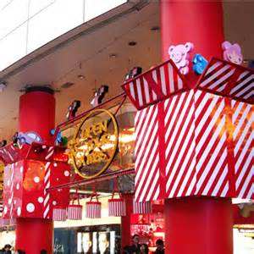

Open Display:

What about this made you choose this?

Decoration Display:

What about this made you choose this?

Closed Display:

What about this made you choose this?

Architectural Display:

What about this made you choose this?

Point of Purchase Display:

What about this made you choose this?

